SVR R2_Score values for 50 startup dataset:

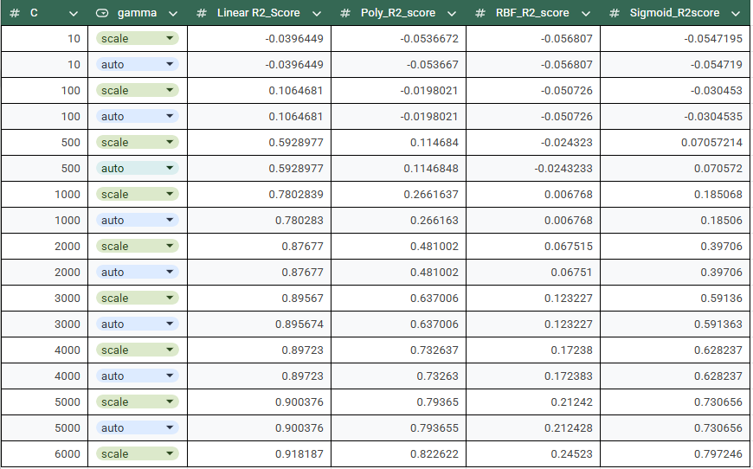

The SVR has the R2_scrore value= 0.918187

Decision Tree Regressor:
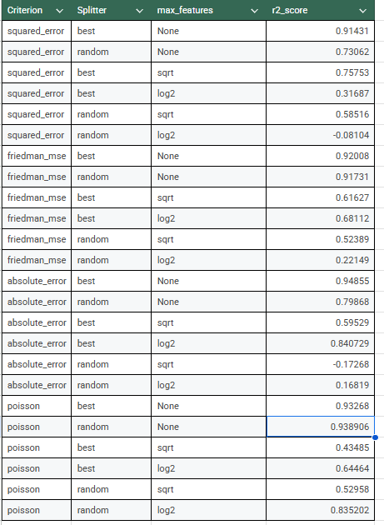
The Decision Tree Regressor has the R2_scrore value=> 0.938906
By comparing the both , The Decision tree model performed well.

